Name

Mathematics Extension 1 Year 12
Surface Area of Pyramids, Cones, Spheres

Book 1 |  | Version: 261002  Feedback:  https://MrDingMaths.com
Contents
Syllabus Content 2
Learning Intention 3

Syllabus Content
MA5-ARE-P-01 applies knowledge of the surface area of right pyramids and cones, spheres and composite solids to solve problems
Solve problems involving surface areas
- Identify the perpendicular heights and slant heights of right pyramids and right cones
- Apply Pythagoras’ theorem to find the slant heights, base lengths and perpendicular heights of right pyramids and right cones
- Solve problems involving the surface areas of right pyramids and compare methods of solution
- Apply the formula to find the curved surface area of right cones: $A=πrl$, where $r$ is the length of the radius and $l$ is the slant height
- Apply the formula to find the surface area of spheres: $A= {4πr}^{2}$, where $r$ is the length of the radius
- Solve problems involving the surface area of solids in a variety of contexts including composite solids

Perpendicular Heights and Slant Heights

- Heights
- A pyramid is a solid with a flat base and triangular faces that join at a point called the apex.
- A cone is like a pyramid but has a circular base.
- The slant height $(l)$ is the sloped distance from the centre of the base length to the apex.
- The perpendicular height $(h)$ is the vertical distance from the base to the apex.
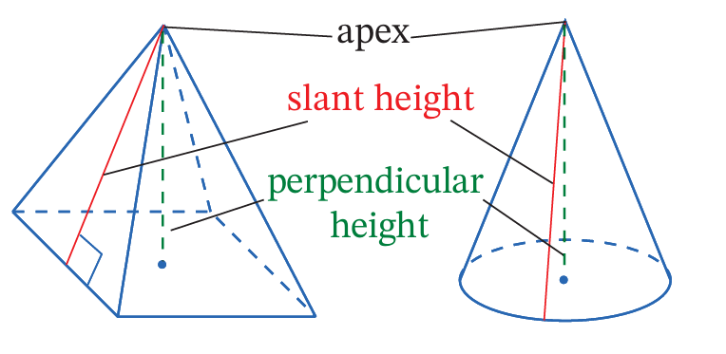

- Identify slant height or perpendicular height
Determine whether the arrow is indicating a slant height or perpendicular height.
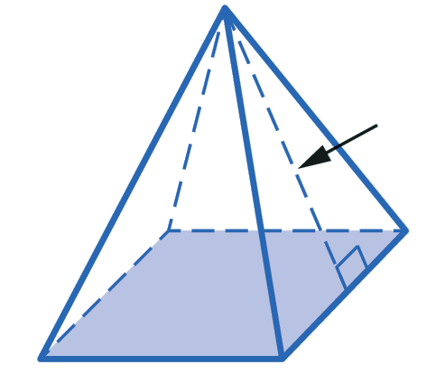 | 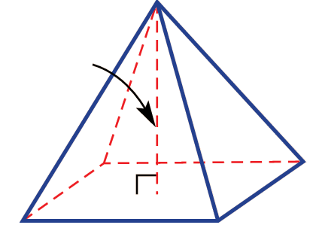 | 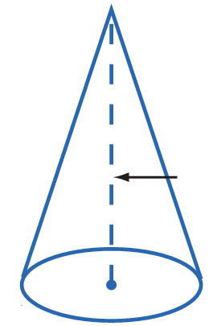
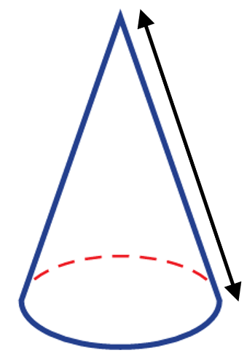 | 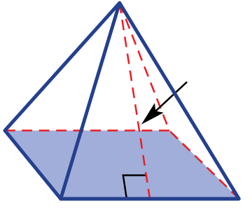 | 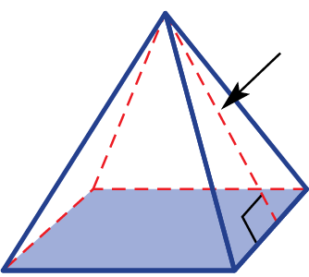
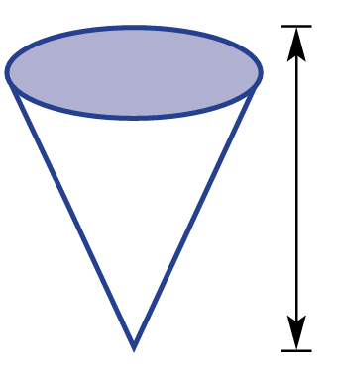 | 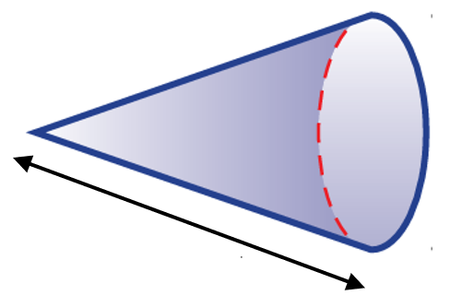 | 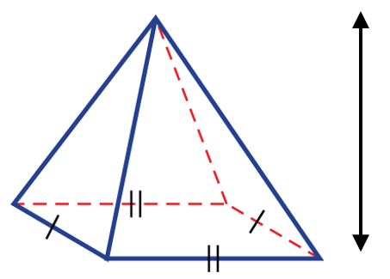
- Calculating Heights
- Using a right-angled triangle, we can find the slant height or perpendicular height with Pythagoras' Theorem.
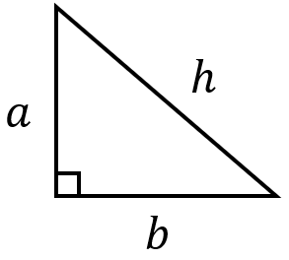
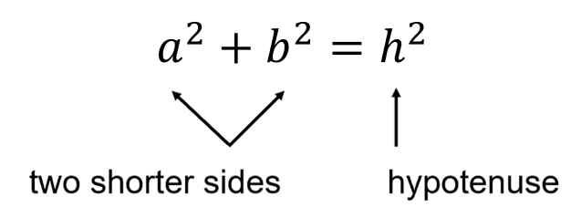

- Example Calculate slant height or perpendicular height
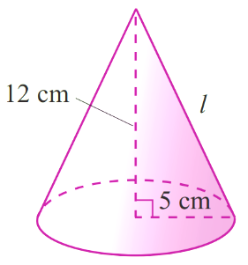  Calculate the unknown value in these solids.  $l^{2}={12}^{2}+5^{2}$  $$l^{2}=169$$  $l=13$ cm | 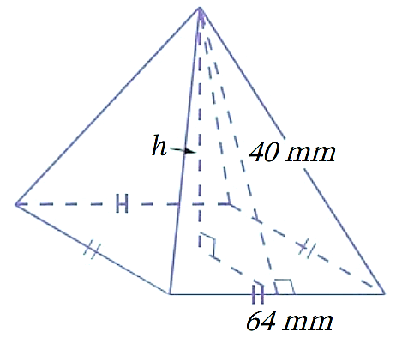  $h^{2}+{32}^{2}={40}^{2}$  $$h^{2}={40}^{2}-{32}^{2}$$  $$h^{2}=576$$  $h=24$ mm

- Guided Practice
Calculate the unknown height in each diagram. Answer in exact surd form.
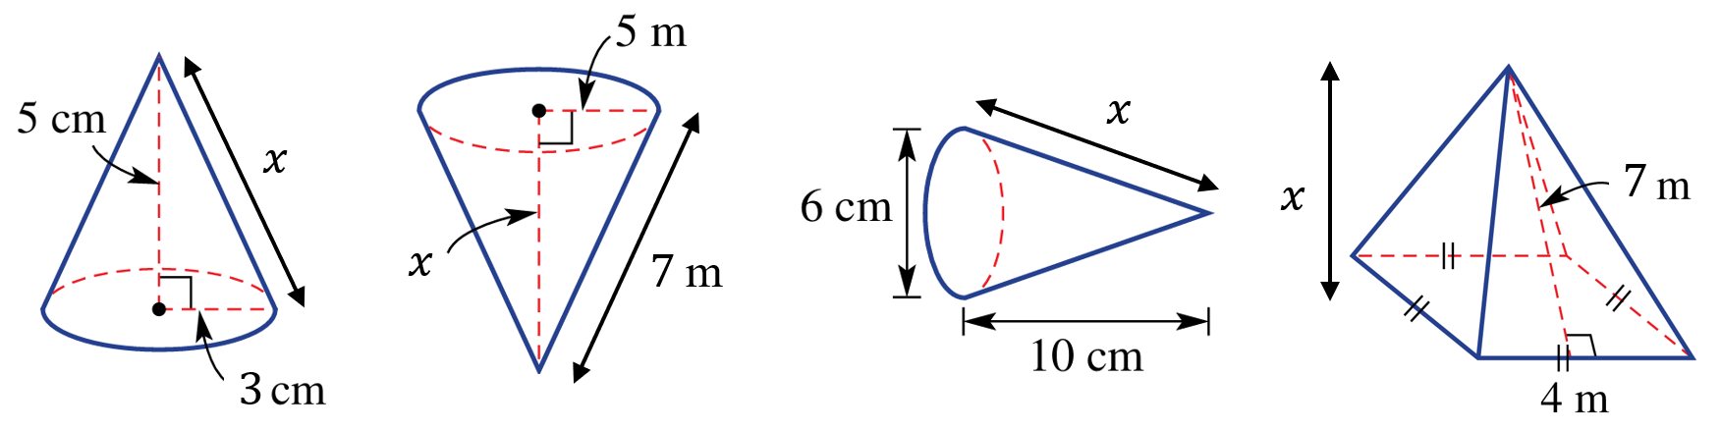  $x=\sqrt{34}$ cm | $x=\sqrt{24}$ m
$x=\sqrt{109}$ cm | $x=\sqrt{45}$ m

Foundation
- You are given the perpendicular height (or altitude).
Calculate the slant height using Pythagoras’ Theorem. Answer in exact surd form if necessary.
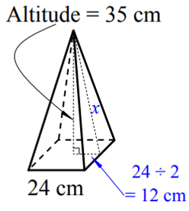  37 cm | 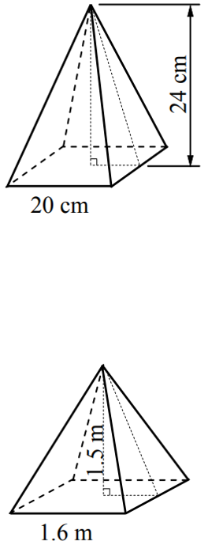  26 cm | 1.7 m
$\sqrt{29}$ cm | 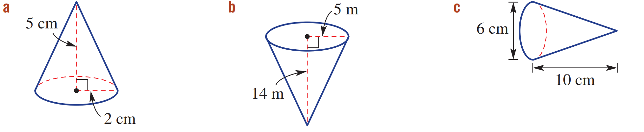  $$l$$  $$l$$  $$l$$  $\sqrt{221}$ m | $\sqrt{109}$ cm
- You are given a side edge. Calculate the slant height using Pythagoras’ Theorem.
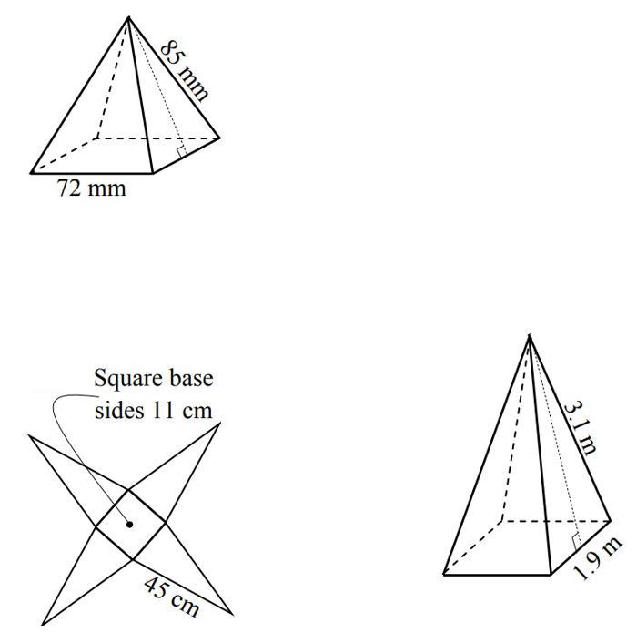  $\sqrt{1994.75}$ cm | 77 mm | $\sqrt{8.7075}$ m
- Find the perpendicular height using Pythagoras’ theorem. Answer in exact surd form.
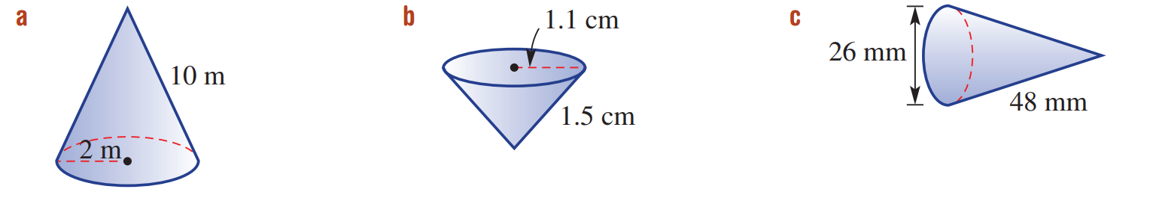  $\sqrt{96}$ m | $\sqrt{1.04}$ cm | $\sqrt{2135}$ mm
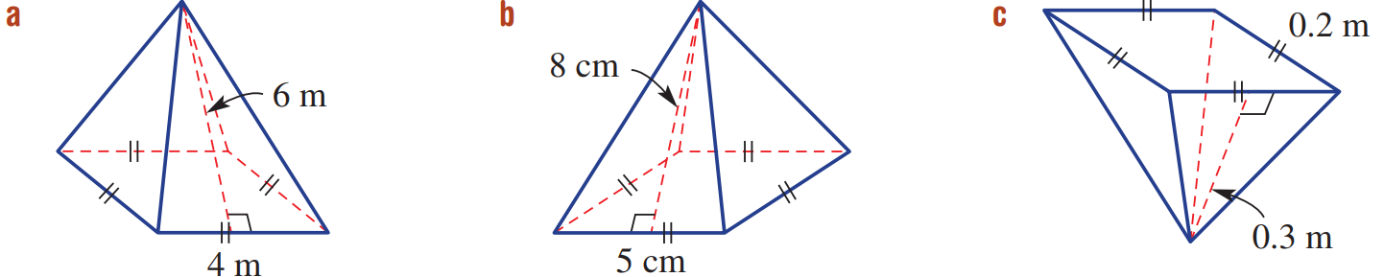  $\sqrt{32}$ m | 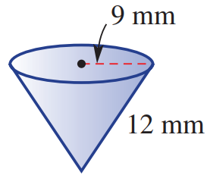  $\sqrt{63}$ mm | $\sqrt{57.75}$ cm

Surface Area of Pyramids: Slant Height Given

- Surface Area of Pyramids
- To calculate the surface area of a pyramid, we must consider its net.
- A pyramid is made up of the base and triangles.
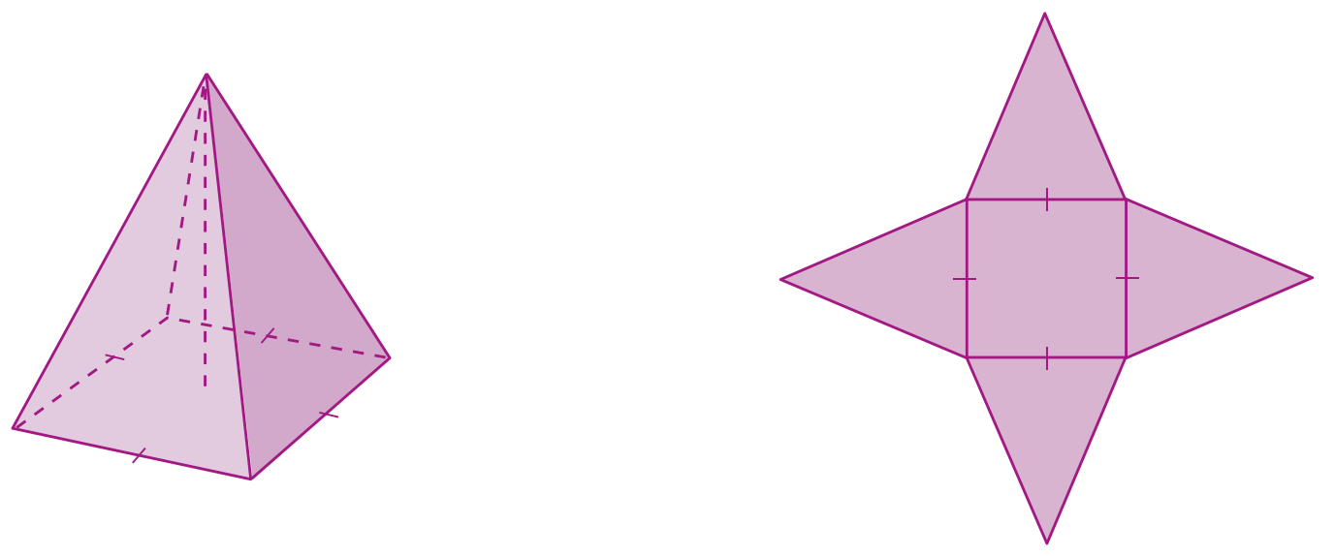

- Example Calculate the surface area of a pyramid from its net
Calculate the surface area of this pyramid.
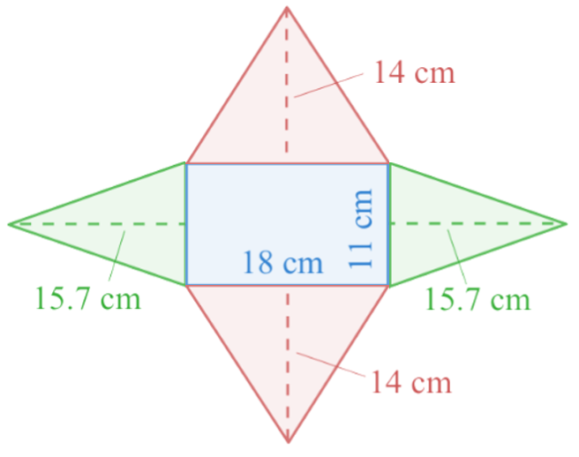
Area of base:
$18×11=198$
Area of front and back triangles:
$$2×\left(\frac{1}{2}×18×14\right)=252$$
Area of side triangles:
$$2×\left(\frac{1}{2}×11×15.7\right)=172.8$$
Total surface area:
$198+252+172.8=622.8$ cm²

- Guided Practice
Calculate the surface area of this pyramid. Round your answer to the nearest whole.
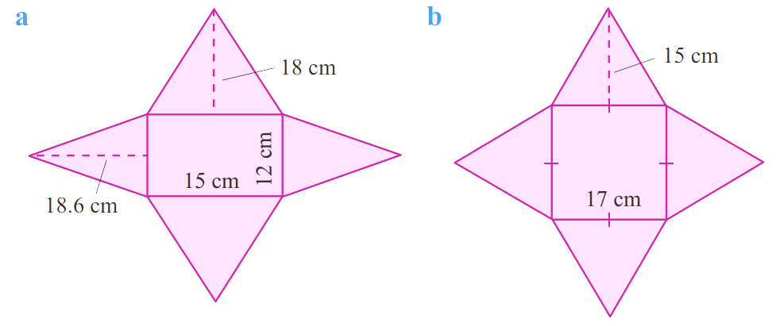  Area of base:  Area of front and back triangles:  Area of side triangles:  Total surface area:  673.2 cm² | Area of base:  Area of front and back triangles:  Area of side triangles:  Total surface area:  799 cm²

Foundation
- Calculate the surface area of these pyramids. Round your answer to the nearest whole.
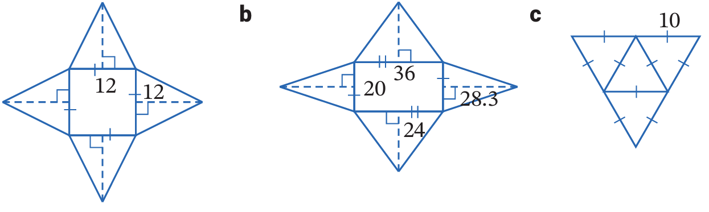  Area of base:  Area of front and back triangles:  Area of side triangles:  Total surface area:  432 cm² | 2150 cm² | 173 cm²
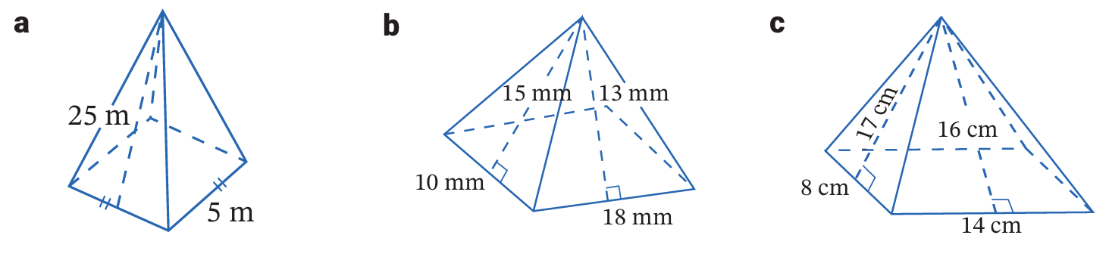  275 m² | 564 mm² | 472 cm²

Surface Area of Pyramids: Find Slant Height

- Surface Area of Pyramids: Find Slant Height
- To calculate the surface area of a pyramid where the slant height is not given:
- Calculate the slant height for each triangular face.
- Calculate the area of each face.

- Example Calculate the surface area of a pyramid with unknown sides
Calculate the surface area of this pyramid. Round your answer to the nearest whole number.
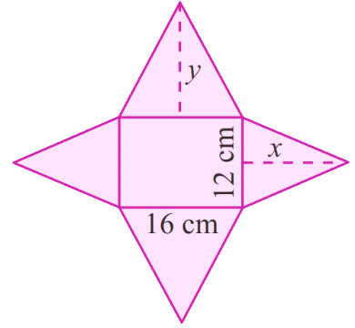
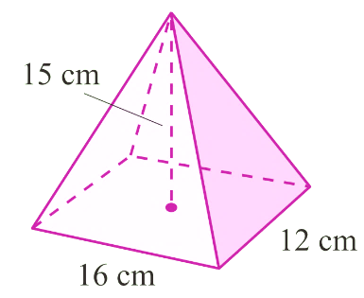

1. Calculate slant heights
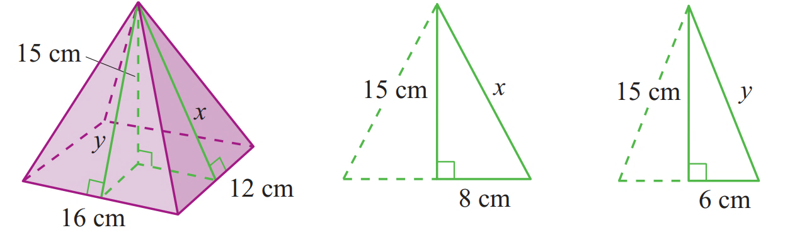

$x^{2}={15}^{2}+8^{2}$  $x^{2}=289$  $x=17 cm$ | $y^{2}={15}^{2}+6^{2}$  $y^{2}=261$  $y=16.16 cm$
2. Calculate area of each face
Area of base: $16×12=192$

Area of front and back triangles:
$$2×\left(\frac{1}{2}×16×16.16\right)=258.56$$
Area of side triangles:
$$2×\left(\frac{1}{2}×12×17\right)=204$$

Total surface area: $192+258.56+204≈255 cm^{2}$

- Guided Practice
- Calculate the surface area of this pyramid.
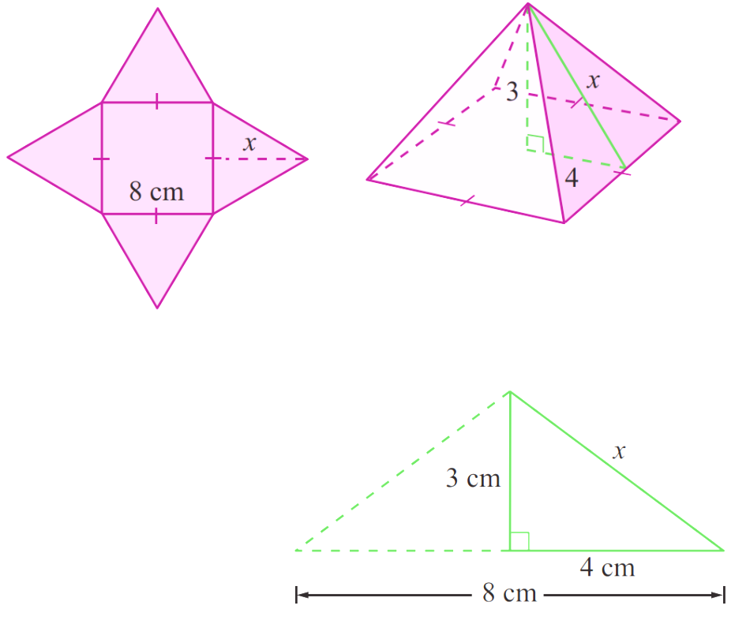

Calculate slant height:

Area of base:

Area of front and back triangles:

Area of side triangles:

Total surface area:

144 cm²

- Calculate the surface area of this pyramid. Answer to the nearest whole.
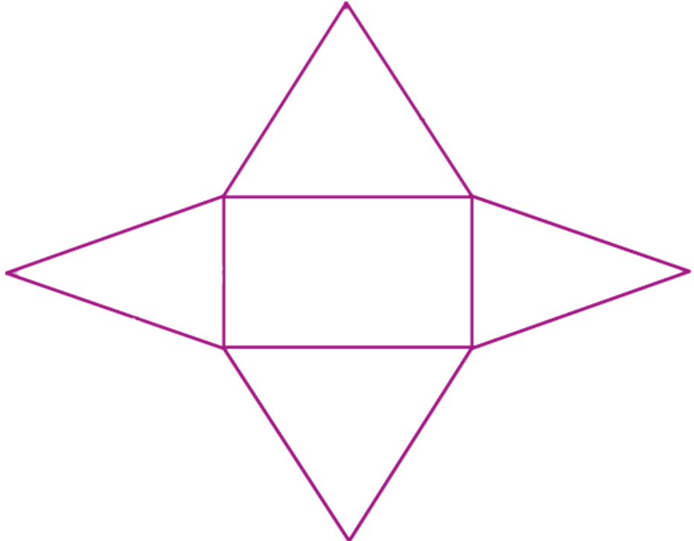
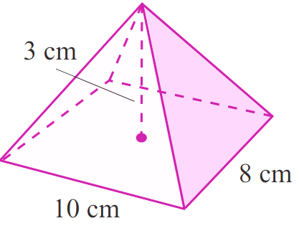

Calculate slant heights:

Area of base:

Area of front and back triangles:

Area of side triangles:

Total surface area:

177 cm²

Foundation
- This right square pyramid has base side length 4 m and vertical height 6 m.
  - Find the slant height in exact form.
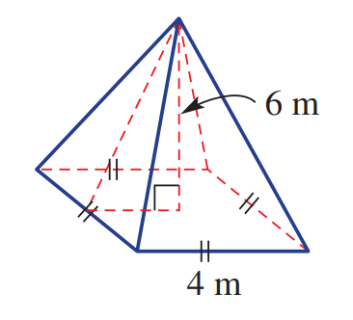

$\sqrt{40}$ m
  - Find the surface area, correct to 1 d.p.

66.6 m²
- Calculate the surface area of these pyramids. You will need to find the slant height.
Round your answer to 1 decimal place, where appropriate.
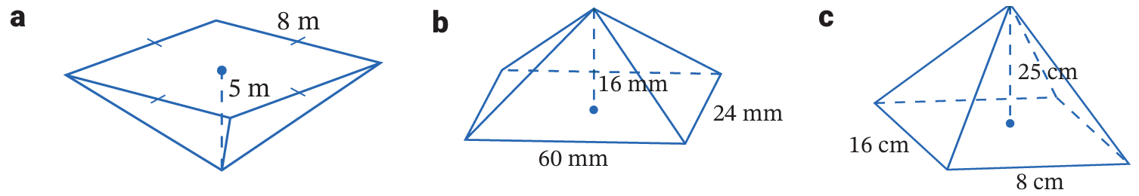  166.4 m² | 3456 mm² | 743.1 cm²

Development
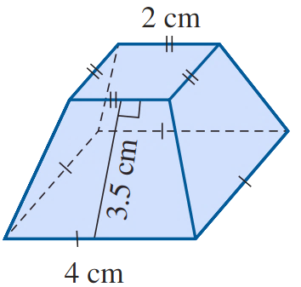
- The solid opposite is called a frustum. It is the portion of a square pyramid that remains after the upper part has been cut off by a plane parallel to its base.
What is the surface area of the frustum? Answer correct to one decimal place.

Top: $2^{2}$
Bottom: $4^{2}$
$$Sides (4 trapeziums):4\left(\frac{3.5\left(2+4\right)}{2}\right)$$
Total = $62$ cm²
- Calculate the surface area of these pyramids.
The given lengths are the base lengths and the edge length.
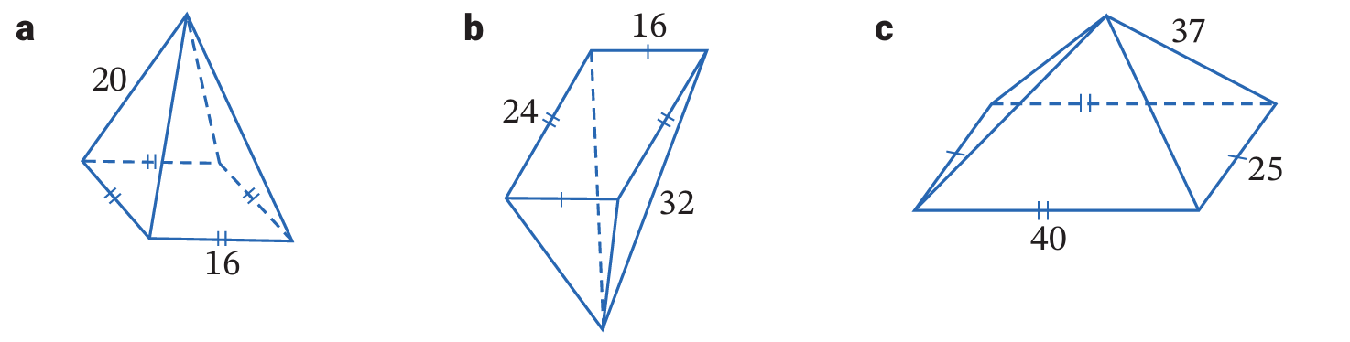  843 cm² | 1592 cm² | 3116 cm²
- Find the surface area of these solids. Round your answer to 1 d.p. where appropriate.
- All faces are right-angled triangles  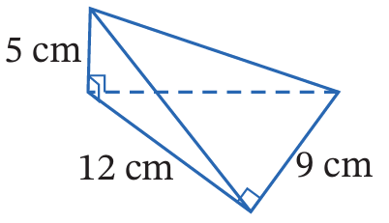  80 cm² | 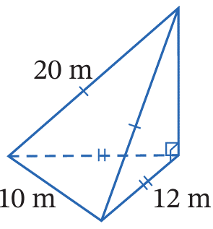  343.4 m²
- Calculate the surface area of these composite solids.
Round your answer to 1 d.p. where appropriate.
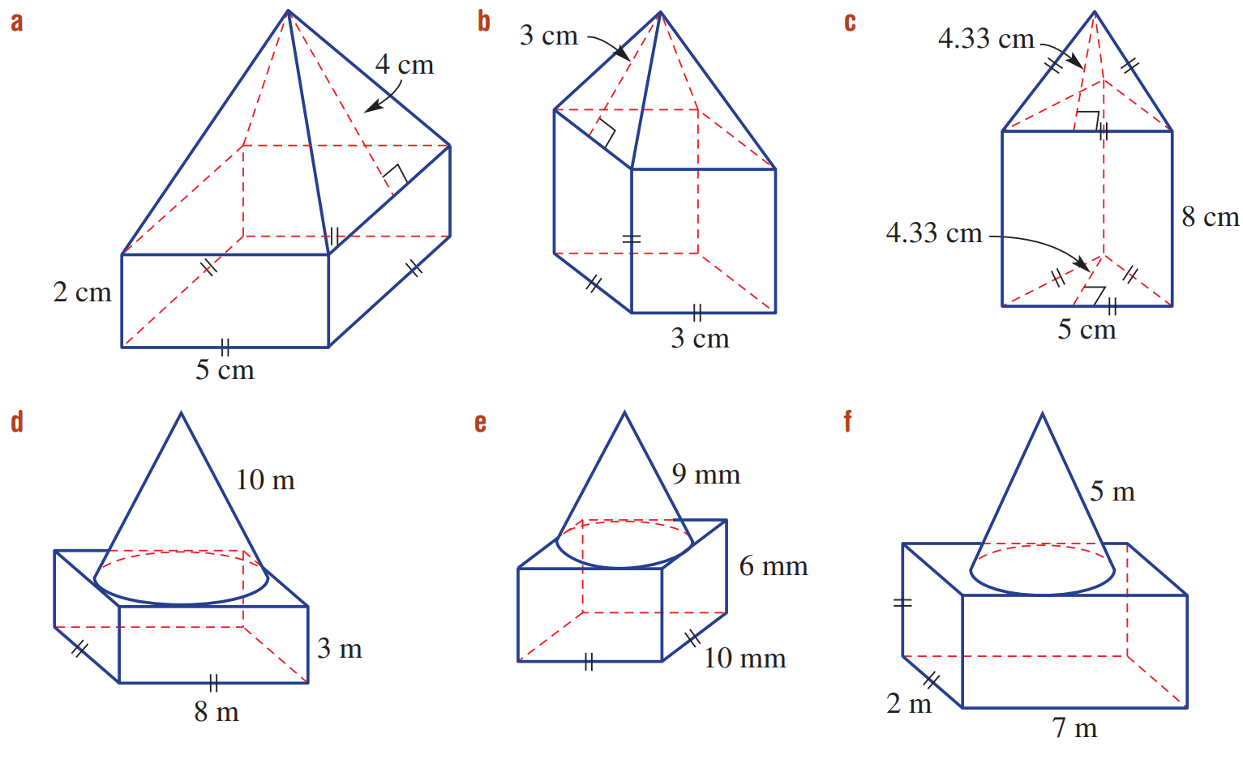  Base: $(5)(5)$  Side rectangles: $(5)(2)×4$  Side triangles: $\frac{\left(5\right)\left(4\right)}{2}$ $×4$  105 cm² | 63 cm² | 163.3 cm²

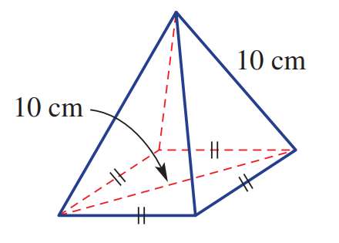
- Calculate the surface area of this pyramid.

Side length of base: $\sqrt{50}$
$$Slant height:\sqrt{{10}^{2}-{\left(\frac{\sqrt{50}}{2}\right)}^{2}}=\sqrt{\frac{175}{2}}$$
$$SA = \left(\sqrt{50}×\sqrt{50}\right)+4\left(\frac{\sqrt{50}×\sqrt{\frac{175}{2}}}{2}\right)$$
= 182.3 cm²
- A square pyramid has a surface area of 4704 m² and a base area of 1764 m².
Find its perpendicular height.

Base length: 42 m
Area of triangular face: 735 m²
Slant height of triangular face: 35 m
Perpendicular height: 28 m

Surface Area of Cones

- Surface Area of a Cone
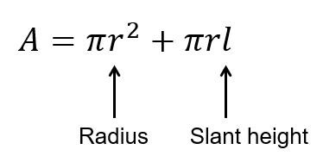
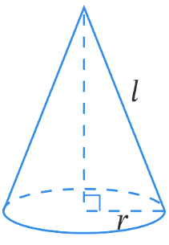

- Example Calculate surface area of a cone
Calculate the surface area of these cones. Round your answer to 1 d.p.
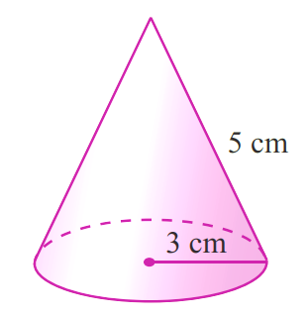  $A=πr^{2}+πrl$  $=π{\left(3\right)}^{2}+π(3)(5)$  $≈47.1 cm^{2}$ | 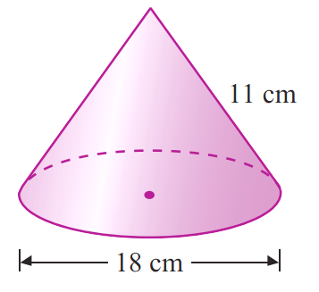  $A=πr^{2}+πrl$  $=π{\left(9\right)}^{2}+π(9)(11)$  $≈565.5 cm^{2}$

- Guided Practice
Calculate the surface area of these cones. Round your answer to 1 d.p.
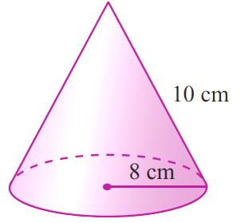  $A=πr^{2}+πrl$  $=$ …………………  $=$ …………………  452.4 cm² | 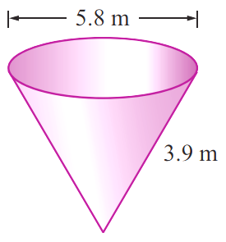  $A=πr^{2}+πrl$  $=$ …………………  $=$ …………………  62.0 cm²

Foundation
- Calculate the surface area of these solids. Round your answer to 2 decimal places.
$A=πr^{2}+πrl$  $=$  $=$  150.80 cm² | 3939.56 cm² | 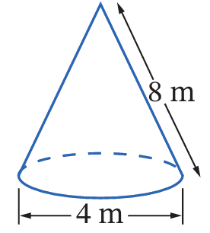  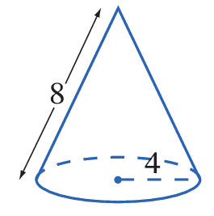  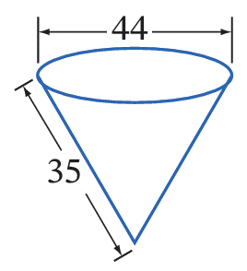  62.83 m²

- Calculate the surface area of these solids. You will need to find the slant height.
Round your answer to 1 decimal place.
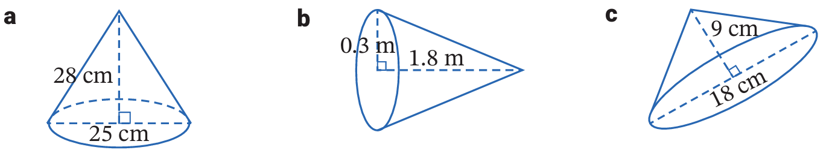  1695.0 cm² | 2.0 m² | 614.3 cm²

- Find the surface area of these cones. Leave your answer in exact form in terms of $π$.
90π m² | 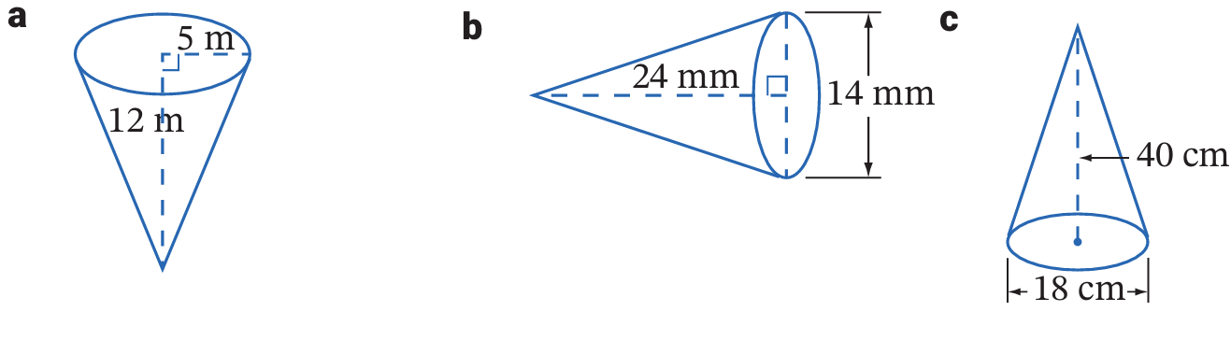  224π mm² | 450π cm²

Development
- A cone with radius 5 cm has a curved surface area of 400 cm².
  - Find the slant height of the cone, correct to 1 decimal place.

25.5 cm
  - Find the height of the cone, correct to 1 decimal place.

25.0 cm
- The curved surface area of a cone is 150 cm² and the radius of the base is 5 cm.
Give answers correct to one decimal place.
  - What is the slant height?

9.5 cm
  - What is the perpendicular height?

8.1 cm
  - What is the surface area of the cone?

228.5 cm²
- Calculate the surface area of the cone. Answer to 2 decimal places.
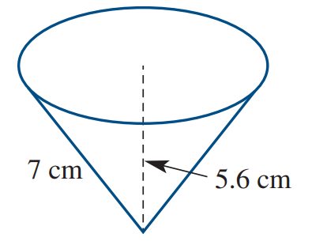

$r=4.2$ cm
$SA=147.78$ cm
- A cone with a radius of 5 cm has a total surface area of 200$π$ cm².
What is the perpendicular height of the cone? Answer in exact form.

$l$ = 35 cm
$∴ h=\sqrt{1200}$ cm

Mastery
- Calculate the surface area of these composite solids. Answer to 1 d.p.
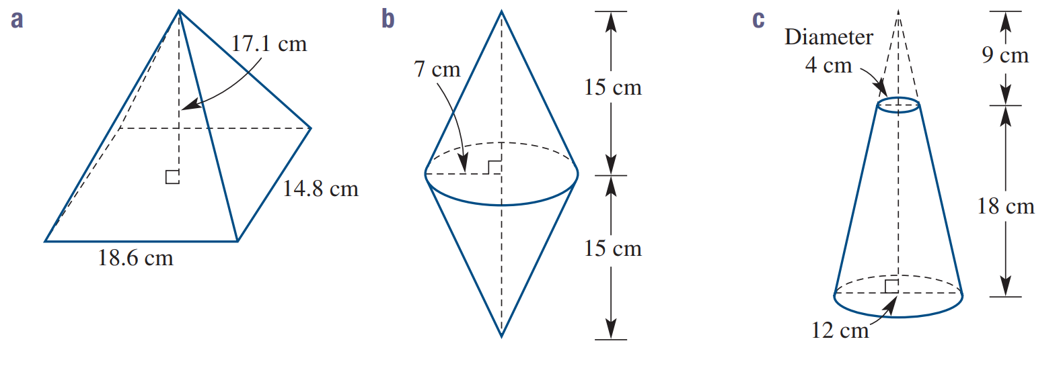  $l=\sqrt{274}$ cm  SA= 728.0 cm² | Top circle: $π{\left(2\right)}^{2}$  Bottom circle: $π{\left(6\right)}^{2}$  Curved surface: $π\left(6\right)\sqrt{765}-π\left(2\right)\sqrt{85}$  SA = 589.1 cm²
299.4 m² | 502.8 mm²
- A cone with a base area of 150 cm² has a total surface area of 2000 cm³.
  - What is the radius of the base? Answer correct to 1 decimal place.

6.9 cm
  - What is the slant height? Answer correct to 1 decimal place.

85.3 cm
  - What is the perpendicular height? Answer correct to nearest whole number

85 cm
- A woodworker uses a rotating lathe to produce a cone with radius 4 cm and height 20 cm.
From that cone the woodworker then cut slices off the sides of the cone to produce a square pyramid of the same height.
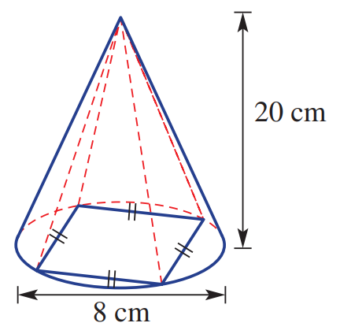
  - Find the exact slant height of the cone.

$4\sqrt{26}$ cm
  - Find the exact side length of the base of the square pyramid.

$4\sqrt{2}$ cm
  - Find the slant height of the pyramid, correct to 3 decimal places.

20.199 cm
  - Find the surface area of the pyramid, correct to 2 decimal places.

260.53 cm²

- Interpret Deriving the formula for the surface area of a cone
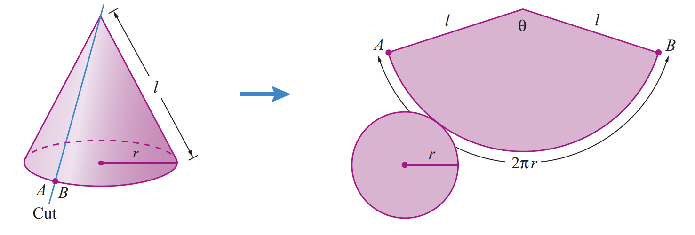
The net of a cone can be obtained by cutting the conical section and unrolling it as shown.

Write an expression for the area of the circular base.

The sector is part of a larger circle with radius $l$.
What is the circumference and area of the larger circle?

The sector has arc length $2πr$.
What is the ratio of the sector arc length to the circumference of the larger circle?

Hence find a simplified expression for the area of the sector using
$$Sector area=Fraction of circle×Area of circle$$

Therefore, what is the surface area of the cone?

Surface Area of Spheres

- Surface Area of Spheres
- A sphere is a perfectly round solid.
- A hemisphere is half a sphere.
  - An open hemisphere is half a hollow sphere. It has no circular face.
  - A closed hemisphere is half a solid sphere. It has a circular face.
Sphere | Hemisphere (open) | Hemisphere (closed)
$$A=4πr^{2}$$ | 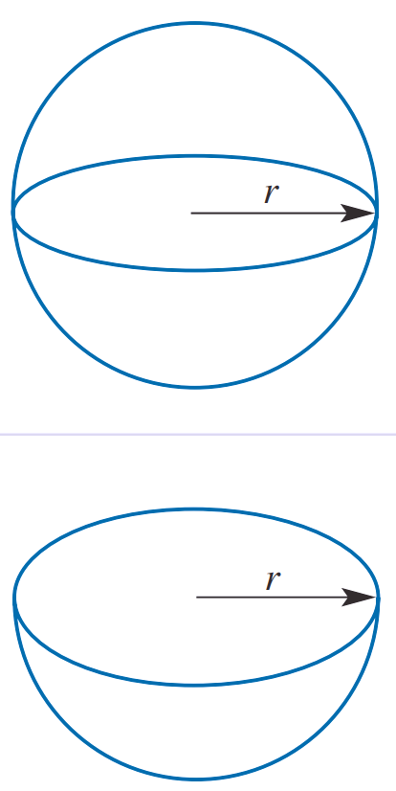  Half a sphere  $$A=\frac{1}{2}×4πr^{2} \\ =2πr^{2}$$ | Half a sphere + top face  $$A=2πr^{2}+πr^{2} \\ =3πr^{2}$$

- Example Calculate surface area of a sphere
Calculate the surface areas of these spheres and open hemispheres to two decimal places.
$$A=4πr^{2} \\ =4π{\left(7\right)}^{2}$$  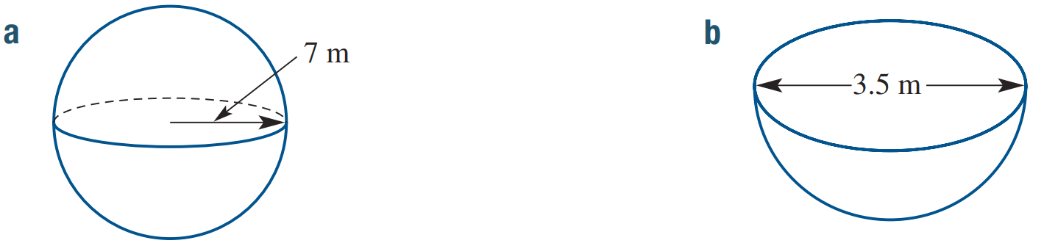  $≈615.75 m^{2}$ | $$A=\frac{1}{2}×4πr^{2} \\ =\frac{1}{2}×4\left(π\right){\left(1.75\right)}^{2}$$  $≈19.24 m^{2}$

- Guided Practice
Calculate the surface areas of these spheres and open hemispheres to 1 d.p.
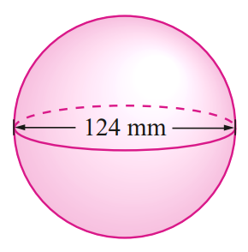  $$A=4πr^{2}$$  $=$  $=$  $48305.$1 mm² | 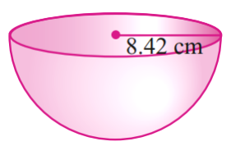  $$A=\frac{1}{2}×4πr^{2}$$  $=$  $=$  $445.5$ cm²

Foundation
- Calculate the surface area of these spheres, correct to 2 decimal places.
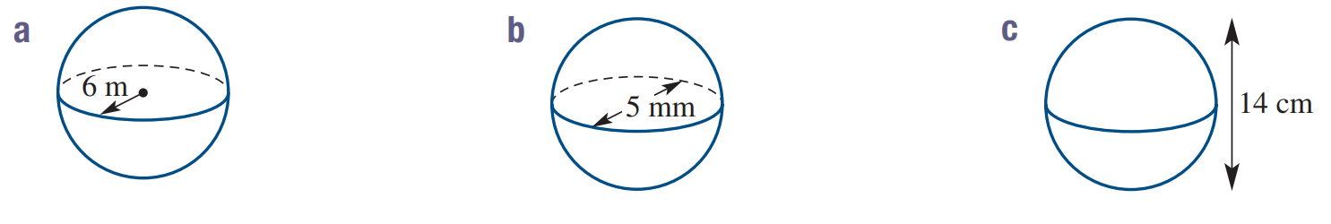  $A=4πr^{2}$  $=$ ………………………  $=$ ………………………  452.39 m² | 78.54 mm² | 615.75 cm²

- Calculate the surface area of these open hemispheres, correct to 2 decimal places.
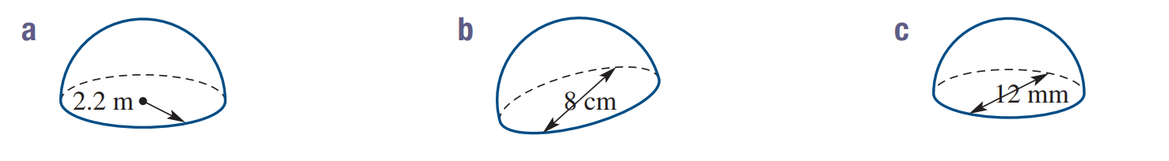  $A=\frac{1}{2}×4πr^{2}$  $=$ ………………………  $=$ ………………………  30.41 m² | 100.53 cm² | 226.19 mm²

- Find the radius of these spheres with the given surface area, correct to 2 decimal places.
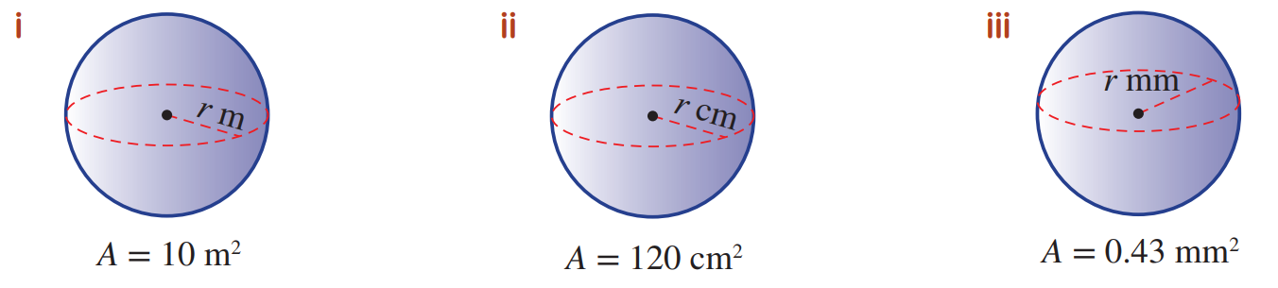  0.89 m | 3.09 cm | 0.18 mm

Development
- How many spheres of 15 cm diameter can be painted with 1 L of glitter paint if the paint covers 10 m²?

1 sphere = $4π{\left(7.5\right)}^{2}=225π$ cm²
$$10 m^{2}×{100}^{2}=100 000 {cm}^{2}$$
$100 000÷225π=$141 spheres
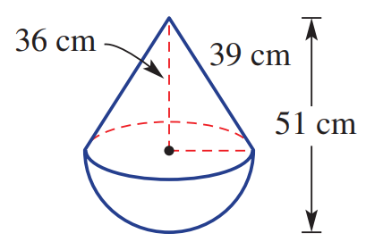
- A water buoy is in the shape shown. Find the surface area, in exact form.

Radius = 15 cm
SA = 1035π cm²
- A hemisphere sits on a cone and two height measurements are given as shown.
Find the surface area of the solid, correct to 1 decimal place.
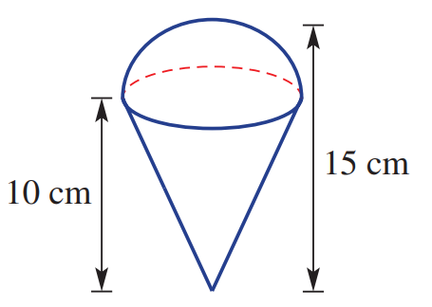

Radius of hemisphere: 5 cm
Slant height: $\sqrt{125}$ cm
SA = 332.7 cm²

Mastery
- Calculate the surface area of these composite solids. Round to the nearest whole.
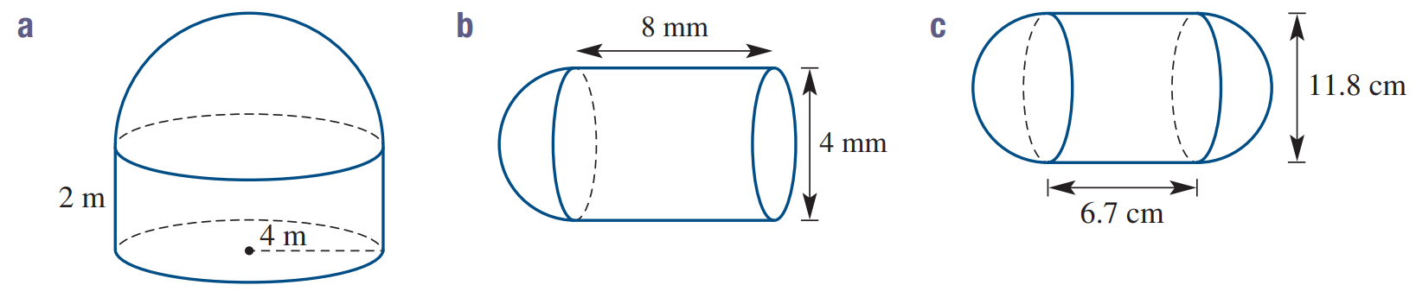  Top hemisphere: 2π(4)²  Curved side: 2π(4)(2)  Bottom: π(4)²  Total: 201 m² | 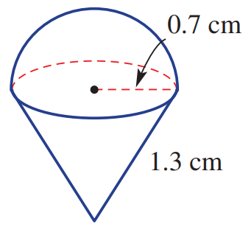  Top hemisphere: 2π(0.7)²  Curved side: π(0.7)(1.3)  Total: 6 cm² | Side hemispheres: 2π(5.9)² $×2$  Curved middle: 2π(5.9)(6.7)  Total: 686 cm²
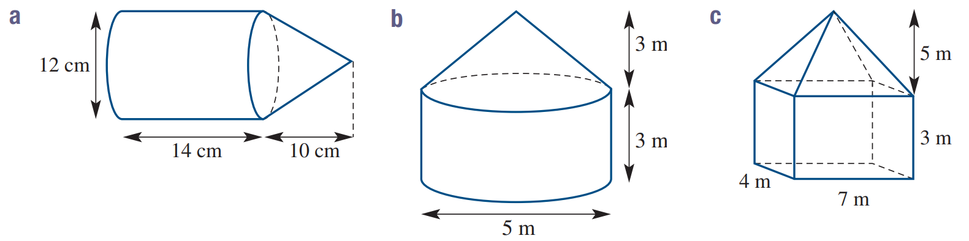  Right cone: π(6)($\sqrt{136}$)  Curved middle: 2π(6)(14)  Left circle: π(6)²  Total: 861 cm² | Top cone: π(2.5)($\sqrt{15.25}$)  Curved middle: 2π(2.5)(3)  Bottom circle: π(2.5)²  Total: 97 m² | $$Top triangles:2\left(\frac{4×\sqrt{37.25}}{2}\right)+2\left(\frac{7×\sqrt{29}}{2}\right)$$  Sides: 2(3)(4)+2(3)(7)  Bottom: 4(7)  Total: 156 m²
- 2014 HSC Standard 2 Band 5
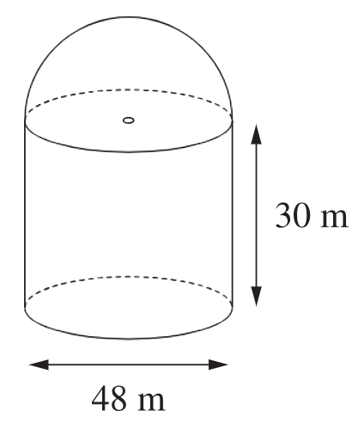
A grain silo is made up of a cylinder with a hemisphere (half a sphere) on top.
The outside of the silo is to be painted. What is the area to be painted, to 1 decimal place?

Curved surface: $2π\left(24\right)\left(30\right)$
Hemisphere: $2π{\left(24\right)}^{2}$
Total: 8143 m²
- 2022 HSC Standard 2 Band 5
Consider the solid below.
The top section is a cylinder with a height of 3 cm and a diameter of 4 cm.
The bottom section is a hemisphere with a diameter of 6 cm.
The cylinder is centred on the flat surface of the hemisphere.
Find the total surface area of the composite solid in cm², correct to 1 decimal place.
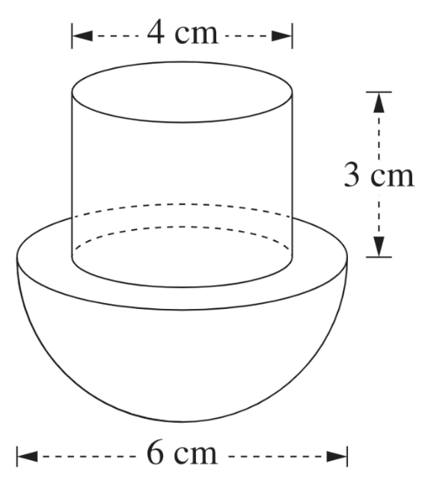

Top-facing surface: $π{\left(3\right)}^{2}$
Curved surface of cylinder: $2π\left(2\right)\left(3\right)$
Bottom hemisphere: $2π{\left(3\right)}^{2}$
Total: 122.5 cm²
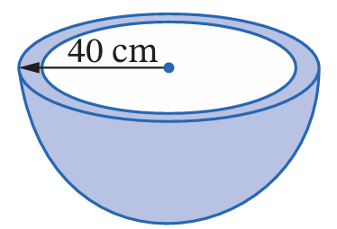
- Find the surface area of this hemispherical bird bath with outer radius 40 cm and 1 cm thick walls. Round your answer to 1 decimal place.

Outer hemisphere: $2π{\left(40\right)}^{2}$
Inner hemisphere: $2π{\left(39\right)}^{2}$
Top: $π{\left(40\right)}^{2}-π{\left(39\right)}^{2}$
Total: 19 858.0 cm²

